ASSIGNMENT – 3
URL Shortener with Redis Caching and MongoDB
Srikrishna O S CSE Section A 3122245001312 SSN COLLEGE OF ENGINEERING

AIM
To extend the URL Shortener from Experiment 2 by adding a Redis cache-aside layer on top of a MongoDB database. The goal is to reduce GET /{shortCode} response time: the first request is a cache miss (fetches from MongoDB and stores the result in Redis), and subsequent requests are cache hits served directly from Redis.

Team Details
S.No | Name | Register Number
1 | Dinesh Kumar J | 3122245001042
2 | Gopinath S | 3122245001048
3 | Harish R | 3122245001055
4 | Srikrishna O S | 3122245001312

CODE - pom.xml
<?xml version="1.0" encoding="UTF-8"?>
<project xmlns="http://maven.apache.org/POM/4.0.0"
xmlns:xsi="http://www.w3.org/2001/XMLSchema-instance"
xsi:schemaLocation="http://maven.apache.org/POM/4.0.0 https://maven.apache.org/xsd/maven-4.0.0.xsd">
<modelVersion>4.0.0</modelVersion>
<parent>
<groupId>org.springframework.boot</groupId>
<artifactId>spring-boot-starter-parent</artifactId>
<version>3.3.4</version>
<relativePath/>
</parent>
<groupId>com.ssn</groupId>
<artifactId>url-shortener</artifactId>
<version>1.0.0</version>
<name>url-shortener</name>
<properties>
<java.version>17</java.version>
</properties>
<dependencies>
<dependency>
<groupId>org.springframework.boot</groupId>
<artifactId>spring-boot-starter-web</artifactId>
</dependency>
<dependency>
<groupId>org.springframework.boot</groupId>
<artifactId>spring-boot-starter-data-mongodb</artifactId>
</dependency>
<!-- new for exp3, this is what lets us use StringRedisTemplate in the controller -->
<!-- spring boot autoconfigures the redis connection just from this + the host/port in application.properties -->
<dependency>
<groupId>org.springframework.boot</groupId>
<artifactId>spring-boot-starter-data-redis</artifactId>
</dependency>
</dependencies>
<build>
<plugins>
<plugin>
<groupId>org.springframework.boot</groupId>
<artifactId>spring-boot-maven-plugin</artifactId>
</plugin>
</plugins>
</build>
</project>

CODE - UrlShortenerController.java
package com.ssn.urlshortener;
import org.springframework.data.redis.core.StringRedisTemplate;
import org.springframework.http.HttpHeaders;
import org.springframework.http.HttpStatus;
import org.springframework.http.ResponseEntity;
import org.springframework.web.bind.annotation.*;
import java.nio.charset.StandardCharsets;
import java.security.MessageDigest;
import java.util.Base64;
import java.util.Optional;
@RestController //class handles http requests
public class UrlShortenerController { //controller
private final UrlMappingRepository repository; //stores repositry olbject which is used to commiuncate with the db
private final StringRedisTemplate redis; //talks to memurai/redis, key = shortcode value = longurl
public UrlShortenerController(UrlMappingRepository repository, StringRedisTemplate redis) {
this.repository = repository;
this.redis = redis;
}
@PostMapping("/shorten") //first api
public ResponseEntity<ShortenResponse> shorten(@RequestBody ShortenRequest request) {
String longUrl = request.getLongUrl();
String shortCode = generateUniqueShortCode(longUrl);
UrlMapping mapping = new UrlMapping(shortCode, longUrl);
repository.save(mapping);
String shortUrl = "http://localhost:8080/" + shortCode;
ShortenResponse response = new ShortenResponse(shortUrl);
return ResponseEntity.status(HttpStatus.CREATED).body(response);
}
@GetMapping("/{shortCode}")
public ResponseEntity<Void> redirect(@PathVariable String shortCode) {
String longUrl = redis.opsForValue().get(shortCode);
if (longUrl != null) {
return ResponseEntity.status(HttpStatus.FOUND)
.header(HttpHeaders.LOCATION, longUrl)
.build();
}
Optional<UrlMapping> result = repository.findByShortCode(shortCode);
if (result.isEmpty()) {
return ResponseEntity.notFound().build();
}
longUrl = result.get().getLongUrl();
redis.opsForValue().set(shortCode, longUrl);
return ResponseEntity.status(HttpStatus.FOUND)
.header(HttpHeaders.LOCATION, longUrl)
.build();
}
private String generateUniqueShortCode(String longUrl) {
String hash = sha256Base64(longUrl);
int length = 6;
String code = hash.substring(0, length); // to get only first few charahcters
while (repository.findByShortCode(code).isPresent() && length < 8) {
length++;
code = hash.substring(0, length);
}
return code;
}
private String sha256Base64(String input) {
try {
MessageDigest digest = MessageDigest.getInstance("SHA-256");
byte[] hashBytes = digest.digest(input.getBytes(StandardCharsets.UTF_8));
return Base64.getUrlEncoder().withoutPadding().encodeToString(hashBytes);
} catch (Exception e) {
throw new RuntimeException("Error generating hash", e);
}
}
}

OUTPUT
POST /shorten
curl -i -X POST http://localhost:8080/shorten -H "Content-Type: application/json" -d @body.json
HTTP/1.1 201 Created
Content-Type: application/json
{"shortUrl":"http://localhost:8080/Ayirwc"}
GET /Ayirwc (cache miss)
curl -i -w " time_total: %{time_total}" http://localhost:8080/Ayirwc
HTTP/1.1 302 Found
Location: https://www.google.com/search?q=system+design
time_total: 0.295927 s
GET /Ayirwc (cache hit)
curl -i -w " time_total: %{time_total}" http://localhost:8080/Ayirwc
HTTP/1.1 302 Found
Location: https://www.google.com/search?q=system+design
time_total: 0.004459 s

SCREENSHOTS
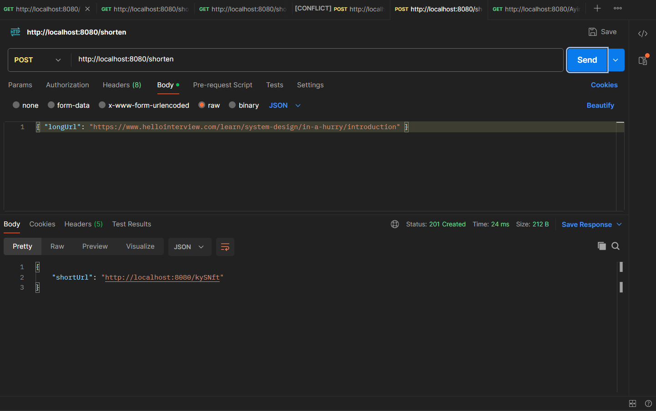
Fig 1 - POST /shorten request and response in Postman
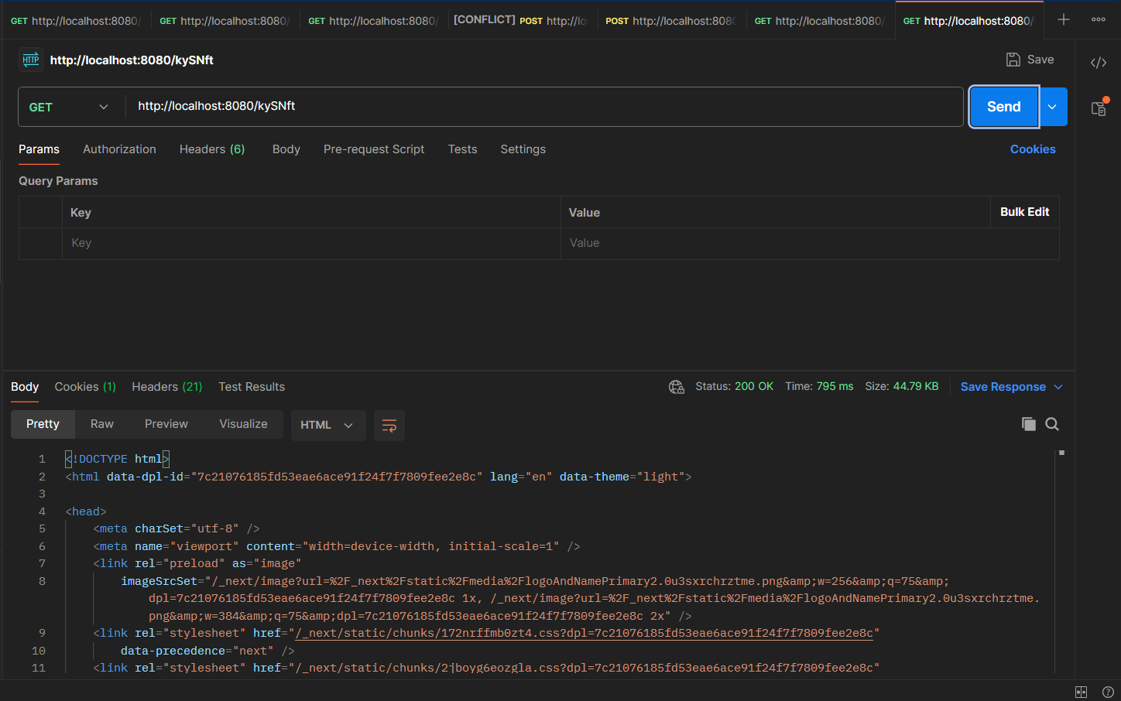
Fig 2 - GET /Ayirwc cache miss: MongoDB lookup took 295.93 ms
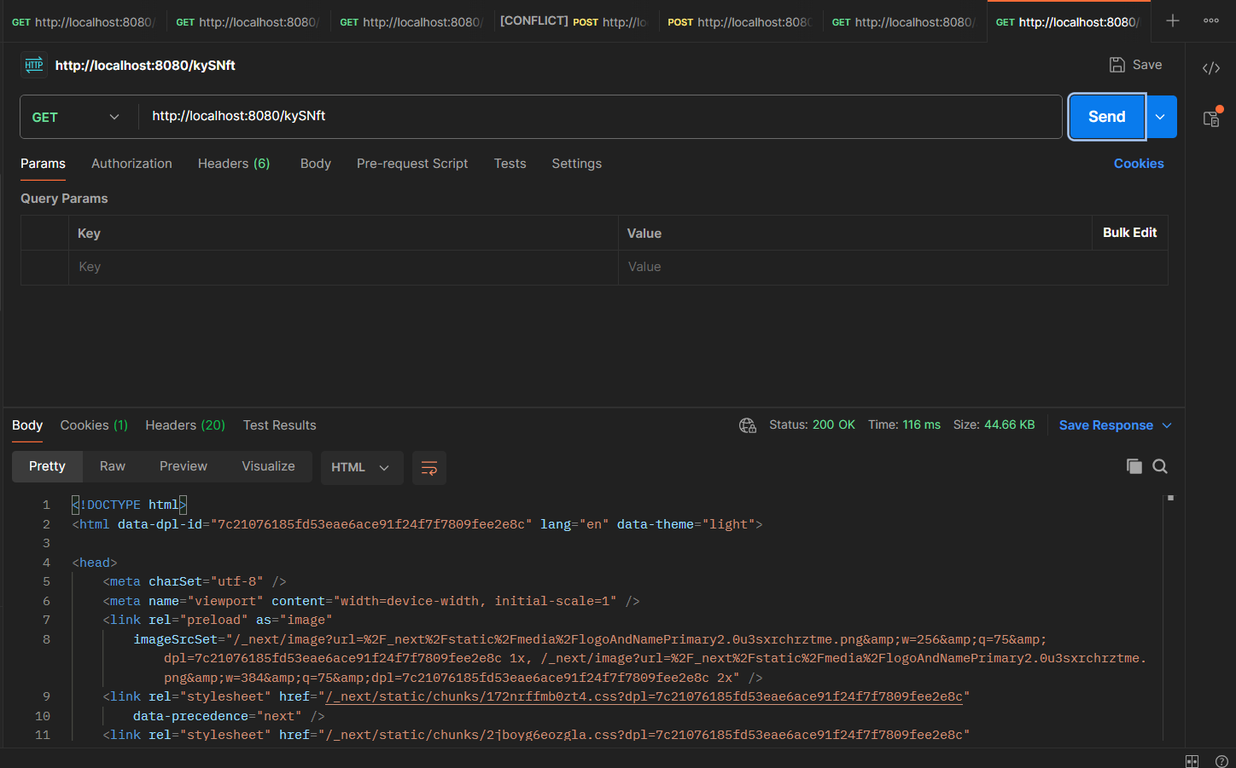
Fig 3 - GET /Ayirwc cache hit: Redis lookup took 4.46 ms

PERFORMANCE METRICS
The cache performance was measured by clearing Redis and sending two consecutive GET /{shortCode} requests. The first request is a cache miss because the long URL is not in Redis, so the application fetches it from MongoDB. The second request is a cache hit because the long URL was stored in Redis on the first request.
Endpoint | Method | Status | Time (ms) | Notes
POST /shorten | POST | 201 Created | - | Returns the generated short URL
GET /Ayirwc | GET | 302 Found | 295.93 | Cache miss: MongoDB lookup
GET /Ayirwc | GET | 302 Found | 4.46 | Cache hit: Redis lookup

TASKS PERFORMED
Task | Description | Result / Output
Set up dependencies | Replaced JPA/H2 with spring-boot-starter-data-mongodb and kept spring-boot-starter-data-redis | MongoDB + Redis dependencies in pom.xml
Configure MongoDB | Updated application.properties to use mongodb://localhost:27017/urlshortener_exp3 | App connects to MongoDB
Convert domain + repository | Switched UrlMapping to @Document and UrlMappingRepository to MongoRepository<String> | Documents stored in url_mapping collection
Implement POST /shorten | Creates short code, stores mapping in MongoDB | 201 Created with shortUrl
Implement cache-aside GET | Checks Redis first; on miss reads MongoDB and writes to Redis | 302 Found on both miss and hit
Test cache behavior | Flushed Redis, POSTed a long URL, then GET the same short code twice | Cache miss = 295.93 ms, cache hit = 4.46 ms
Generate screenshots | Captured POST, cache-miss GET, and cache-hit GET responses | Three Postman screenshots included

LEARNING OUTCOMES

